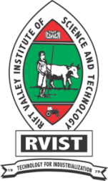**The Rift Valley Institute of Science and Technology**

*ISO 9001:2008 Quality Management System*

The Board of Management designed the Performance Contract FY 2015/2016 and set various targets for implementation during the Financial Year. Among these set targets are Vision 2030 Flagship projects that include the following:

1. Biometric System Installation
2. Completion of Library
3. Rehabilitation of Laboratory

Dairy Cow Breeding Project

Capacity Improvement of the Bakery Project

The Biometric system will be used to improve service delivery in Admission, Registration of Students, Library and Catering. The upcoming Library once completed will provide a seating capacity of upto 1500 users. Renovation of Laboratory is targeted to improve the facility in the Physical Science Laboratory. The Dairy Breeding project is meant to improve on the dairy herd both in the Institute and the community. The Bakery project capacity will be improved in terms products variety and the transport fleet for the distribution and sale o the products.

The Library project is funded by the Government of Kenya (GoK) while the rest of projects are funded by the Institute.

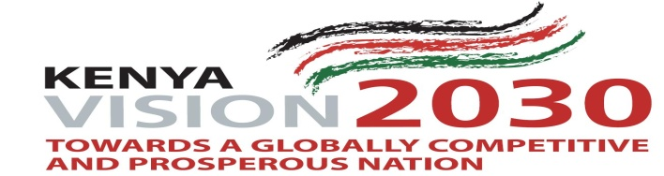

Prepared by: **Performance Contract Co-coordinator**

**Mr. Willy Rop**